Simulating Euros Mini Project

Introduction
This mini project uses data from previous European championships (or Euros) to attempt to model the outcome of the Euros in 2024. The project assesses the feasibility of a generalised linear model (GLM) with a Poisson family to model - using the ranks of the two teams and whether the team is at home as predictors - the score and thus the outcome of a game.

The group stages were constructed to mirror the groups in the Euros 2024 but the knockout stages were simulated by randomly picking the matches between each team. Additionally, games in the knockout stages which were a draw in 90 miuntes went to 30 minutes of extra time, with an appropriately scaled distribution. If the game was still a draw at the end of this time, then a winner was randomly selected by a coin flip.

The probability of each team’s progression was calculated by using a Monte Carlo simulation. The tournament was run 100,000 times using this model and the proportion of which a team made it to each round was recorded. Additionally, parametric bootstrapping with a sample size of 1000 was used to estimate a 95% confidence interval for each team’s probabilities at each different stage.

Justification of Model Choice
Full Model:
$$Goals \sim {Rank}_{Self}+{Rank}_{Opp}+Host+Neutral$$
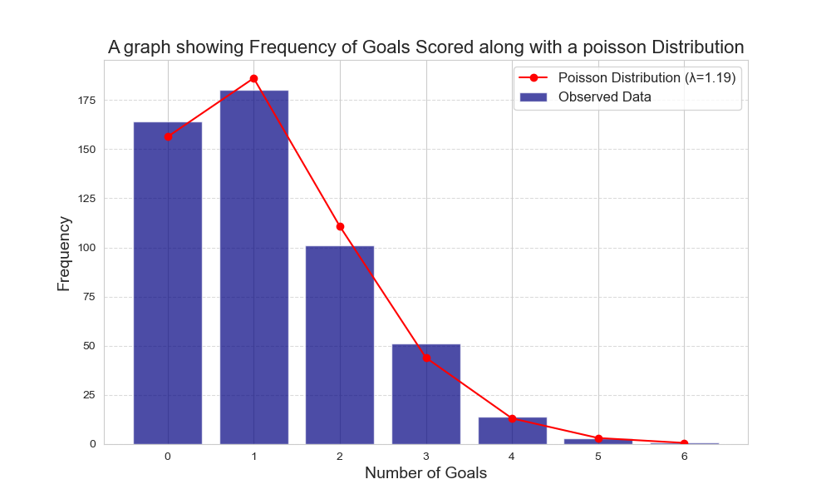
The frequency of football goals in 90 minutes are a discrete and non-negative distribution which is modelled well by a Poisson distribution (lambda = 1.19), as demonstrated by the visualisation. This is further supported by a chi² test (p = 0.62 > 0.05) which confirms that there is not a significant difference between a Poisson distribution with lambda =1.19 and our distribution. Furthermore, in football analytics, goals are often considered to be statistically independent [1]. This study also demonstrates the reasonable effectiveness of the Poisson family of GLMs at modelling football games, despite their simplicity. These factors and tests all justify the choice of a Generalised Linear Model with a Poisson family to model the rate of goals scored by teams in each match.

Additionally, using multiple log likelihood ratio tests, I assessed whether a reduced model would better model the data. However, each test demonstrated that our model was significantly better than the null model, a model just containing Rank terms (Rank_{Self} and Rank_{Opp}), and a model containing just the home advantage terms (Host and Neutral). Additionally, all individual parameter’s significance was tested using the same ratio test. All these tests concluded that all of our parameters were statistically significant. Thus, the full model was used to fit the parameters and estimate the goal rate for individual teams.

Rank data is used since it provides a single statistic which reasonably represents the strength of a team. Using the ranks of the two teams together allows us to estimate the goal rate of the two in a match up and thus allows for a single variable that we can easily incorporate into regression.

Model Results and Comparison with Results of Euro 2024
This section will analyse the results of the model and detail the effectiveness of our model at predicting the outcome of the 2024 Euros. This will be done by comparing the model’s round by round results to the actual results of the 2024 Euros.

Visualisations are used to demonstrate the chances of teams to reach different stages of the tournament. Past the Round of 16 teams with a lower than 5% percent chance of qualifying for that stage are excluded from the visualisations to consolidate the information presented by the figure. Additionally, bars are colour coded to indicate the relative probabilities of teams qualifying for that stage. The bars with darker colour are the teams with the highest probability of qualifying for that round.

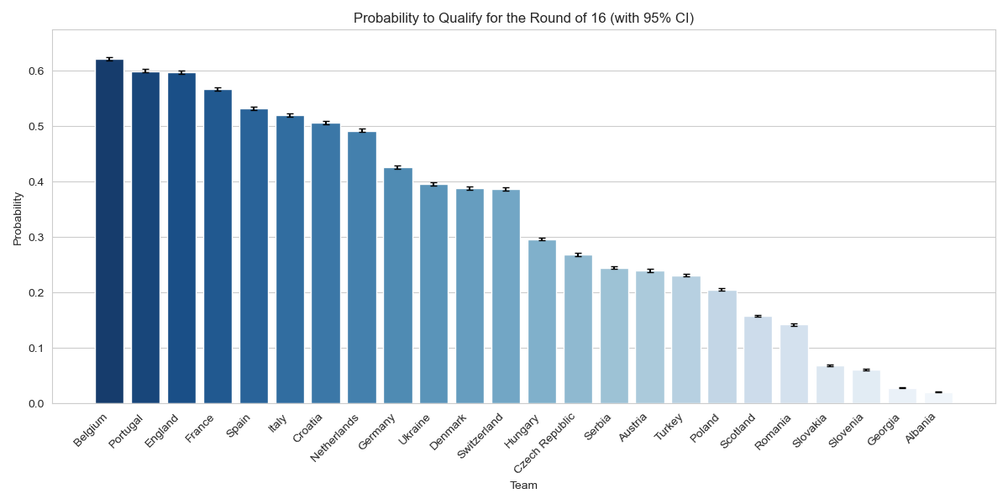
Round by Round Analysis

Round of 16 Analysis
The model correctly estimates that Spain, Germany, Denmark, Portugal, England, France, Belgium, Switzerland, Italy, Netherlands, Austria make it to the final 16 of the tournaments, a success rate of 68.75%. However, it significantly overrates Croatia and Ukraine. Additionally, it overrates Hungary, Serbia, and the Czech Republic, who do not make it to the final 16. Conversely, it underrates Georgia, Slovenia, Romania, Turkey, and Slovakia all of whom make it to the final round of 16.

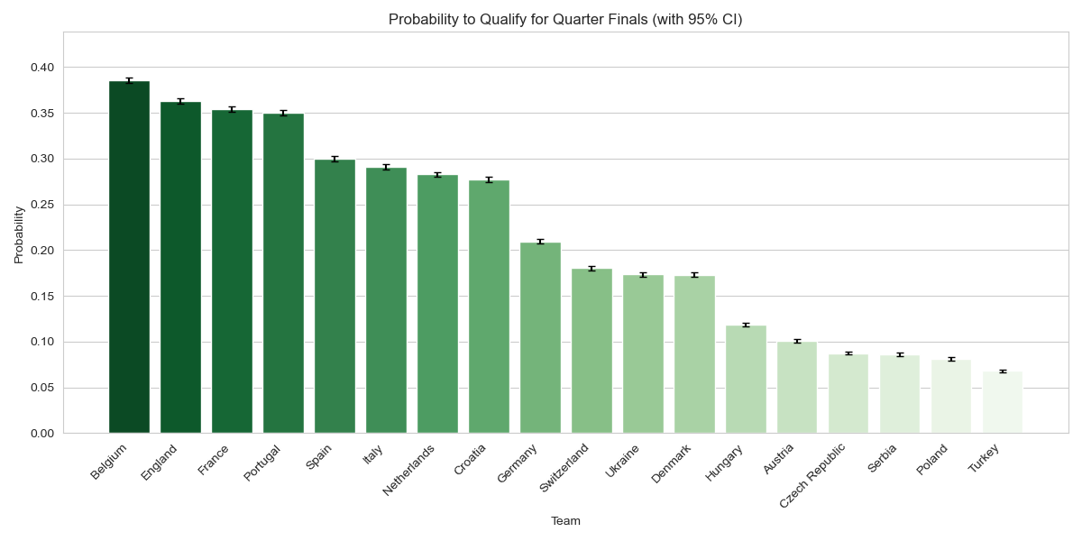
Quarter Final Analysis
The model correctly estimates that Spain, Portugal, France, Netherlands, England make it to the quarters however, it does not estimate that Germany, Turkey, and Switzerland make it. In their place it estimates that Belgium, Croatia, and Italy have higher probabilities of making it to the quarters.

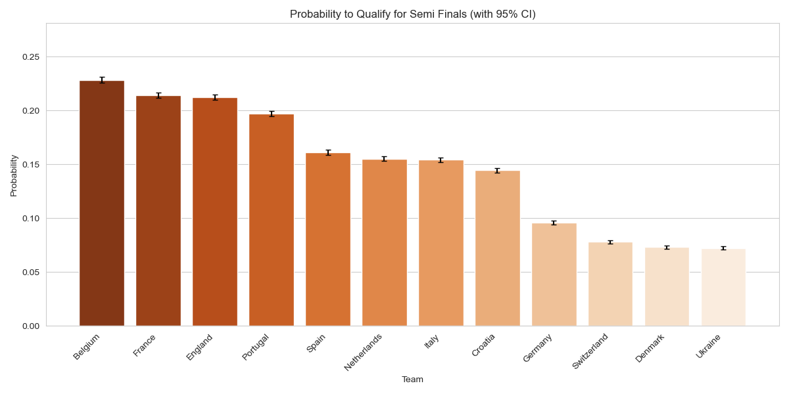
Semi-Final Analysis
The model correctly estimates that England and France will make it to the Semi-Finals but predicts Belgium and Portugal as the final two contenders. In reality, it was Spain and the Netherlands.

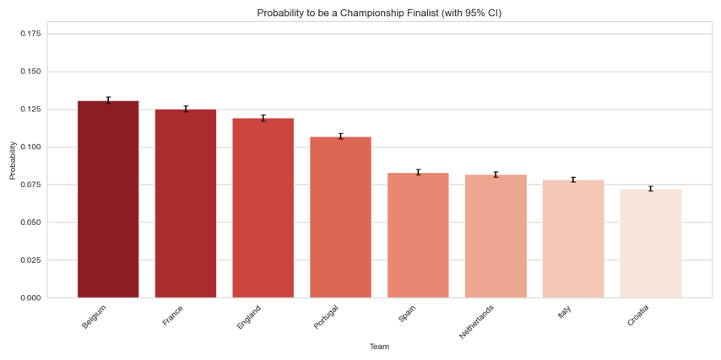
Finals Analysis
The model predicts for a matchup between France and Belgium in the Final, which in reality occurred in the Round of 16, resulting in France progressing. France was beaten by Spain in the semi-finals who progressed to face England in the finals.

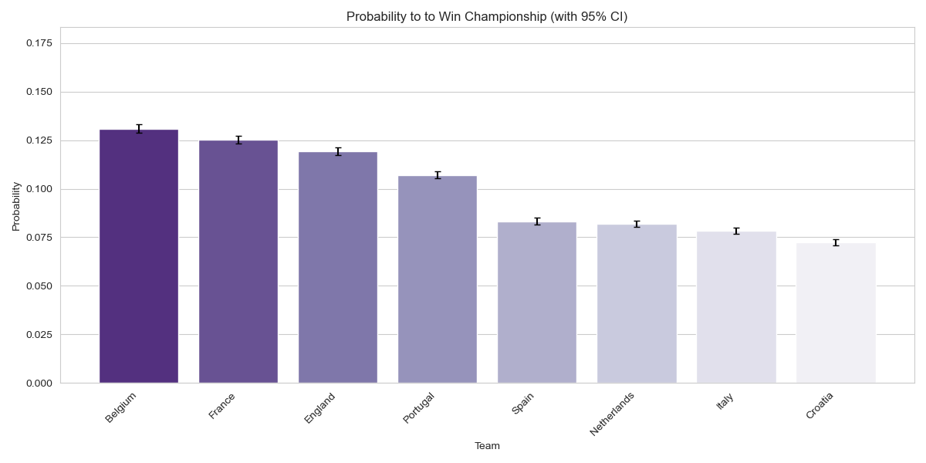
Championship Analysis
Belgium were estimated to have the highest probability of winning, nearly 5% higher than the actual winners, Spain. Who the model pipped to be the 5th most likely team to win the tournament.

Model Limitations

Limitations of Using Ranking as Main Predictor
There is a phrase in modelling -“rubbish in, rubbish out”. This suggests that your model is only as good (or bad) as the data that you are providing it. Thus, using FIFA World Ranking as the primary predictor of how two teams will stack up against one another provides a significant limitation to the effectiveness of the model.

World ranking summarises a team’s form and probability of success into a single number is – an immense simplification of a team’s aptitude on the football pitch. It does not provide us with the insight of how well a team is truly playing, or how well it has played for that matter, to accurately predict their future success. By looking at the way the FIFA world rankings are calculated we can break down this simplification.

The FIFA world rankings were revamped in 2018 to use the Elo-style ranking system which. The formula of which can be found below [2]

$$P_{New }= P_{Old}+I(W-W_{E})$$

Where, $P_{New } :$ New Ranking Points, $P_{Old} :$ Old Ranking Points, I = Importance factor of the match, W = Result of the match, W_{E} = Expected Result (Based upon the rankings difference between the two teams).

This section will focus on the R factor of the formula. The R can have the value of 1, 0.5, or 0 for a win, draw, or loss respectively, if a game does not go to penalties. Additionally, R can equal 0.75 and 0.5 for a winning or losing team respectively in a penalty shootout. Despite this, for the large part, a world ranking simply demonstrates that a team has simply won, lost, or drawn a match but it does not consider how close a game was, how well either team has been playing (and hence whether they really deserved to win or lose the matches that contribute to their ranking) or any factors relating to home advantage, with the exception of the 2006-2018 rating system [3]. Although, there has been some attempt to include the home advantage and the R factor can include some nuance for games which go to penalties, these factors do not adequately account for the nuance and back and forth of a football game. Thus, this will mean that teams can be easily over or underrated by the rankings system based off the binary outcome of the match.

Efforts can be made to rectify this issue by including factors such as recent player and team performance metrics, which of course our model does not include. The consequences of this lack is detailed below.

Lack of Player Metrics
The use of player specific metrics would allow us to better model the performance of a team and thus use this data to make more informed predictions for future matches with that player present. Metrics such as minutes played, pass accuracy, distance covered, assists, and goals can help us to ascertain the value that a player has brought to the pitch. These metrics can then help to uncover the bigger picture of how well a team played by breaking it down into player specific metrics.

This information is also essential for predicting future game outcomes by assessing the impact of individual player on the squad’s strength. In our current model, if the players for the Albanian (the statistically weakest team) and Belgian (the statistically strongest team) teams swapped then our model would still predict Albania have the lowest win rate and Belgium to have the highest. This is an extreme and hypothetical case but demonstrates the shortfall of the model. Assessing the impact of individual players would allow for our model to predict the effect of an individual’s exclusion or inclusion from the squad because of injury or match bans. This would allow us model to better predict the outcome of matches.

Lack of Team Metrics
Additionally, team metrics can allow our model to “perceive” a more nuanced view to the outcome of games, thus allowing for more advanced predictions of future match ups. Additionally, more complex models such as that used by Yuqing Yang [4] use metrics such as shots on goal, completed passes, defensive actions, possession, and market value as team based metrics to predict the outcome of matches. Using this data to train the model will allow the model to take into account influential actions within the game and thus ascertain how influential each of these actions are on the games’ outcome. Thus, this can allow the model to better understand whether a team has been playing well based on alternative metrics from just its world ranking.

Limitations of Using FIFA World Rankings in Particular
The FIFA World Rankings have undergone 4 significant transformations in our period of concern (1996-2024). The rankings were introduced in 1992, and developed in 1999[5], 2006 [6], and 2018 [7]. These rankings varying greatly in complexity, factor weighting and factor inclusion. As a result, this means that our model is attempting to fit the same parameters to what is in effect 4 different types of ranking. This will introduce further uncertainty to our parameter fitting leading to a lack of precision in our model. This is likely an example of overfitting our model to data that is arguably no longer useful or applicable.

Limitations in the Model Tournaments Structure
Arguably the greatest limitation of my model which is not regarding the parameters or GLM used is likely the fact that the tournament structure is not properly represented in my code. In the knockout rounds teams are randomly assigned their opponents which is not consistent with the bracket structure used in the tournament. This means that match ups do not occur in the order that one might expect them to. This is likely why France and Belgium’s probabilities of winning the tournament is so high since the model neglects that France and Belgium were likely to meet in the round of 16, as they did in the actual tournament. This means that the model underrates the probability that only one of the two teams will make to the quarter and semi-finals of the tournament. Perhaps the simplest improvement to the model would be to amend this which would likely improve its ability to simulate the tournament significantly.

Additionally, the model does not make any attempt at predicting games which go to penalties, it randomly assigns a winner. This could be modelling using historical data also and would give a more accurate representation of the tournament. One would imagine this would make the model more accurate at predicting the outcome of the tournament.

Conclusion
This mini project demonstrates how a Poisson GLM can use ranks and home advantage to simulate the outcome of the Euros in 2024. While the model does provide a general picture of the potential outcome of the tournament its limitations in both its fitted parameters and its tournament structure limit its effectiveness. The discrepancies in the results section highlight the following core limitations: (1) The model oversimplifies the game by relying on solely FIFA rankings which cannot capture the player dynamics or provide a thorough description of a team’s recent performance, and (2) that a simulated bracket structure is necessary to reflect real world match ups.

Despite the models’ limitations and the model’s simplicity the project demonstrates the basic feasibility of Poisson based GLMs for modelling the outcome of football matches. Moving forward, using more team and player metrics alongside better emulations of tournament and game structure will be essential to creating a model which is more informative.

Bibliography

[1] M. J. Maher, ‘Modelling association football scores’, Stat. Neerlandica, vol. 36, no. 3, pp. 109–118, 1982, doi: 10.1111/j.1467-9574.1982.tb00782.x.
[2] ‘edbm045h0udbwkqew35a-pdf.pdf’. Accessed: Jan. 26, 2025. [Online]. Available: https://digitalhub.fifa.com/m/f99da4f73212220/original/edbm045h0udbwkqew35a-pdf.pdf
[3] ‘FIFA.com - Ranking Procedure and Schedule’. Accessed: Jan. 26, 2025. [Online]. Available: https://web.archive.org/web/20070604211354/http://www.fifa.com/worldfootball/ranking/procedure/men.html
[4] ‘Research on the winning factors of football matches based on machine learning’, Acad. J. Math. Sci., vol. 4, no. 4, 2023, doi: 10.25236/AJMS.2023.040408.
[5] A. Vorobyev, I. Solntsev, and N. Osokin, Football Development Index: Rationale, Methodology, and Application. Lexington Books, 2017.
[6] ‘FIFA.com - Great expectations’. Accessed: Jan. 26, 2025. [Online]. Available: https://web.archive.org/web/20080612172346/http://www.fifa.com/worldfootball/ranking/news/newsid%3D104272.html
[7] B. Rumsby, ‘Fifa to review rankings system after friendlies harm England’s World Cup seeding’, The Telegraph, Sep. 04, 2017. Accessed: Jan. 26, 2025. [Online]. Available: https://www.telegraph.co.uk/football/2017/09/04/fifa-review-rankings-system-friendlies-harm-englands-world-cup/

